还得是int main

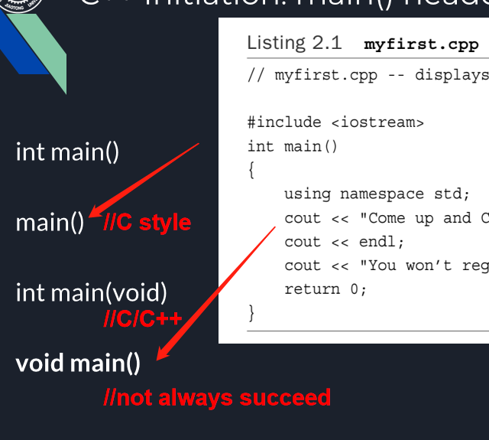

在标准C++以前，都是用#include< [iostream.h](https://www.baidu.com/s?wd=iostream.h&tn=44039180_cpr&fenlei=mv6quAkxTZn0IZRqIHckPjm4nH00T1Y3ry7-mH0dm1TvPHNWn1mk0ZwV5Hcvrjm3rH6sPfKWUMw85HfYnjn4nH6sgvPsT6KdThsqpZwYTjCEQLGCpyw9Uz4Bmy-bIi4WUvYETgN-TLwGUv3EPjnkrHmdP16LP1TvrjmvnjfY" \t "https://blog.csdn.net/luguocai321/article/details/_blank)>这样的写法的，因为要包含进来的头文件名就是 [iostream.h](https://www.baidu.com/s?wd=iostream.h&tn=44039180_cpr&fenlei=mv6quAkxTZn0IZRqIHckPjm4nH00T1Y3ry7-mH0dm1TvPHNWn1mk0ZwV5Hcvrjm3rH6sPfKWUMw85HfYnjn4nH6sgvPsT6KdThsqpZwYTjCEQLGCpyw9Uz4Bmy-bIi4WUvYETgN-TLwGUv3EPjnkrHmdP16LP1TvrjmvnjfY" \t "https://blog.csdn.net/luguocai321/article/details/_blank)。标准C++引入了 [名字空间](https://www.baidu.com/s?wd=%E5%90%8D%E5%AD%97%E7%A9%BA%E9%97%B4&tn=44039180_cpr&fenlei=mv6quAkxTZn0IZRqIHckPjm4nH00T1Y3ry7-mH0dm1TvPHNWn1mk0ZwV5Hcvrjm3rH6sPfKWUMw85HfYnjn4nH6sgvPsT6KdThsqpZwYTjCEQLGCpyw9Uz4Bmy-bIi4WUvYETgN-TLwGUv3EPjnkrHmdP16LP1TvrjmvnjfY" \t "https://blog.csdn.net/luguocai321/article/details/_blank)的概念，并把iostream等标准库中的东东封装到了std [名字空间](https://www.baidu.com/s?wd=%E5%90%8D%E5%AD%97%E7%A9%BA%E9%97%B4&tn=44039180_cpr&fenlei=mv6quAkxTZn0IZRqIHckPjm4nH00T1Y3ry7-mH0dm1TvPHNWn1mk0ZwV5Hcvrjm3rH6sPfKWUMw85HfYnjn4nH6sgvPsT6KdThsqpZwYTjCEQLGCpyw9Uz4Bmy-bIi4WUvYETgN-TLwGUv3EPjnkrHmdP16LP1TvrjmvnjfY" \t "https://blog.csdn.net/luguocai321/article/details/_blank)中，同时为了不与原来的头文件混淆，规定标准C++使用一套新的头文件，这套头文件的文件名后不加.h扩展名，如iostream、string等等，并且把原来 [C标准库](https://www.baidu.com/s?wd=C%E6%A0%87%E5%87%86%E5%BA%93&tn=44039180_cpr&fenlei=mv6quAkxTZn0IZRqIHckPjm4nH00T1Y3ry7-mH0dm1TvPHNWn1mk0ZwV5Hcvrjm3rH6sPfKWUMw85HfYnjn4nH6sgvPsT6KdThsqpZwYTjCEQLGCpyw9Uz4Bmy-bIi4WUvYETgN-TLwGUv3EPjnkrHmdP16LP1TvrjmvnjfY" \t "https://blog.csdn.net/luguocai321/article/details/_blank)的头文件也重新命名，如原来的 [string.h](https://www.baidu.com/s?wd=string.h&tn=44039180_cpr&fenlei=mv6quAkxTZn0IZRqIHckPjm4nH00T1Y3ry7-mH0dm1TvPHNWn1mk0ZwV5Hcvrjm3rH6sPfKWUMw85HfYnjn4nH6sgvPsT6KdThsqpZwYTjCEQLGCpyw9Uz4Bmy-bIi4WUvYETgN-TLwGUv3EPjnkrHmdP16LP1TvrjmvnjfY" \t "https://blog.csdn.net/luguocai321/article/details/_blank)就改成cstring(就是把.h去掉，前面加上字母c)，所以头文件包含的写法也就变成了#include <iostream>。  
并不是写了#include<iostream>就必须用using namespace std;我们通常这样的写的原因是为了一下子把std [名字空间](https://www.baidu.com/s?wd=%E5%90%8D%E5%AD%97%E7%A9%BA%E9%97%B4&tn=44039180_cpr&fenlei=mv6quAkxTZn0IZRqIHckPjm4nH00T1Y3ry7-mH0dm1TvPHNWn1mk0ZwV5Hcvrjm3rH6sPfKWUMw85HfYnjn4nH6sgvPsT6KdThsqpZwYTjCEQLGCpyw9Uz4Bmy-bIi4WUvYETgN-TLwGUv3EPjnkrHmdP16LP1TvrjmvnjfY" \t "https://blog.csdn.net/luguocai321/article/details/_blank)的东东全部暴露到全局域中（就像是直接包含了 [iostream.h](https://www.baidu.com/s?wd=iostream.h&tn=44039180_cpr&fenlei=mv6quAkxTZn0IZRqIHckPjm4nH00T1Y3ry7-mH0dm1TvPHNWn1mk0ZwV5Hcvrjm3rH6sPfKWUMw85HfYnjn4nH6sgvPsT6KdThsqpZwYTjCEQLGCpyw9Uz4Bmy-bIi4WUvYETgN-TLwGUv3EPjnkrHmdP16LP1TvrjmvnjfY" \t "https://blog.csdn.net/luguocai321/article/details/_blank)这种没有名字空间的头文件一样），使标准C++库用起来与传统的iostream.h一样方便。如果不用using namespace std;使用标准库时就得时时带上名字空间的全名，如std::cout << "hello" << std::endl;  
     #include "iostream"与#include<iostream>的区别：前者先在 [当前目录](https://www.baidu.com/s?wd=%E5%BD%93%E5%89%8D%E7%9B%AE%E5%BD%95&tn=44039180_cpr&fenlei=mv6quAkxTZn0IZRqIHckPjm4nH00T1Y3ry7-mH0dm1TvPHNWn1mk0ZwV5Hcvrjm3rH6sPfKWUMw85HfYnjn4nH6sgvPsT6KdThsqpZwYTjCEQLGCpyw9Uz4Bmy-bIi4WUvYETgN-TLwGUv3EPjnkrHmdP16LP1TvrjmvnjfY" \t "https://blog.csdn.net/luguocai321/article/details/_blank)找iostream文件，找不到再去系统头文件路径找，后者反之。因此，做为一个良好的习惯，在包含系统头文件时尽量用<>，而在包含自己的工程中的头文件时用""。  
<iostream>和<iostream.h>不一样，前者没有后缀，实际上，在编译器include文件夹里面可以看到，二者是两个文件，打开文件就会发现，里面的代码是不一样的。  
后缀为.h的头文件c++标准已经明确提出不支持了，早些的实现将标准库功能定义在全局空间里，声明在带.h后缀的头文件里，c++标准为了和C区别开，也为了正确使用 [命名空间](https://www.baidu.com/s?wd=%E5%91%BD%E5%90%8D%E7%A9%BA%E9%97%B4&tn=44039180_cpr&fenlei=mv6quAkxTZn0IZRqIHckPjm4nH00T1Y3ry7-mH0dm1TvPHNWn1mk0ZwV5Hcvrjm3rH6sPfKWUMw85HfYnjn4nH6sgvPsT6KdThsqpZwYTjCEQLGCpyw9Uz4Bmy-bIi4WUvYETgN-TLwGUv3EPjnkrHmdP16LP1TvrjmvnjfY" \t "https://blog.csdn.net/luguocai321/article/details/_blank)，规定头文件不使用后缀.h。  
因此，当使用<iostream.h>时，相当于在c中调用库函数，使用的是全局 [命名空间](https://www.baidu.com/s?wd=%E5%91%BD%E5%90%8D%E7%A9%BA%E9%97%B4&tn=44039180_cpr&fenlei=mv6quAkxTZn0IZRqIHckPjm4nH00T1Y3ry7-mH0dm1TvPHNWn1mk0ZwV5Hcvrjm3rH6sPfKWUMw85HfYnjn4nH6sgvPsT6KdThsqpZwYTjCEQLGCpyw9Uz4Bmy-bIi4WUvYETgN-TLwGUv3EPjnkrHmdP16LP1TvrjmvnjfY" \t "https://blog.csdn.net/luguocai321/article/details/_blank)，也就是早期的c++实现；当使用< iostream>的时候，该头文件没有定义全局 [命名空间](https://www.baidu.com/s?wd=%E5%91%BD%E5%90%8D%E7%A9%BA%E9%97%B4&tn=44039180_cpr&fenlei=mv6quAkxTZn0IZRqIHckPjm4nH00T1Y3ry7-mH0dm1TvPHNWn1mk0ZwV5Hcvrjm3rH6sPfKWUMw85HfYnjn4nH6sgvPsT6KdThsqpZwYTjCEQLGCpyw9Uz4Bmy-bIi4WUvYETgN-TLwGUv3EPjnkrHmdP16LP1TvrjmvnjfY" \t "https://blog.csdn.net/luguocai321/article/details/_blank)，必须使用namespace std；这样才能正确使用cout。  
#include <iostream.h>  
using namespace std; 则出错  
所以 要么写成  
#include <iostream >  
using namespace std;  
要么写成  
#include <iostream.h>  
当然最好是前种

只是使用了cout了，没有用endl 所以不行。

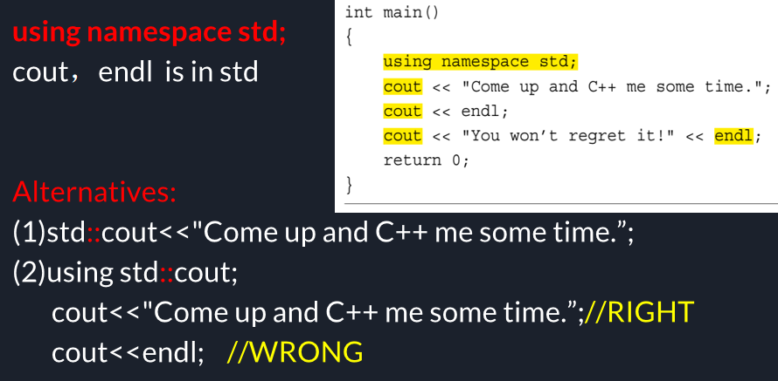

函数调用：

